New Lead: Text Template 1

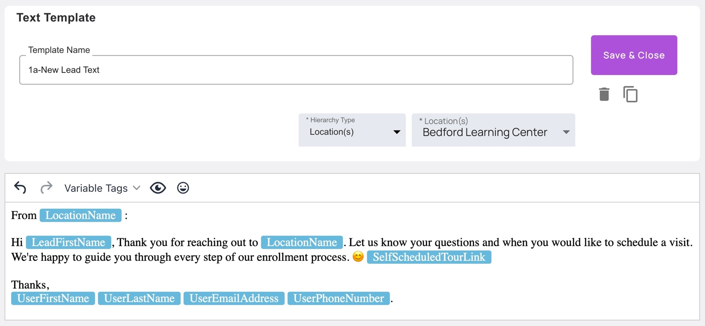Scheduling a Tour: Text Template 2

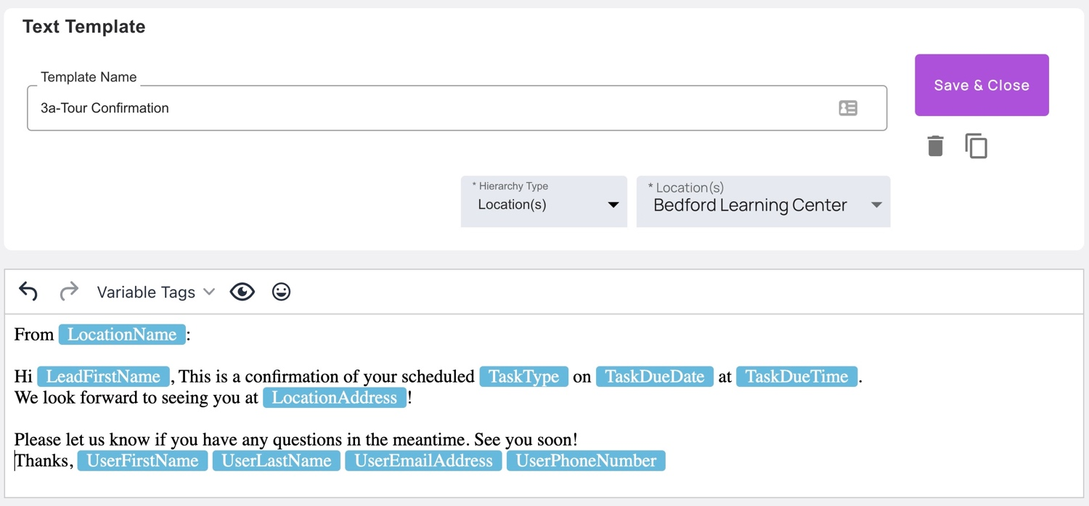Tour Scheduled Reminder: Text Template 3

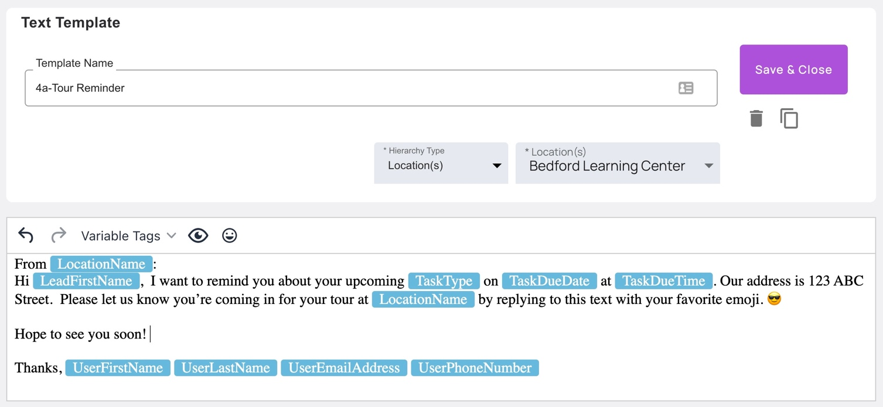Post-Tour Follow-Up Text: Template 4

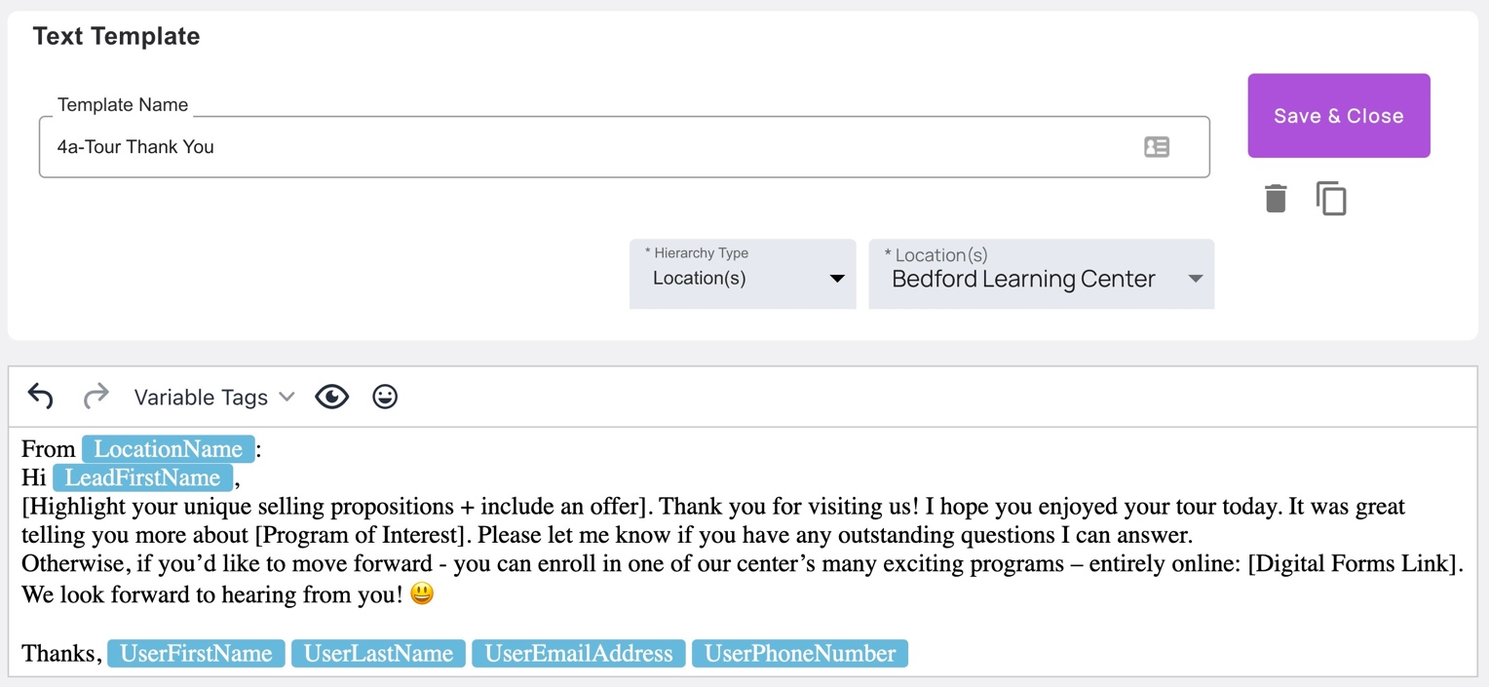Registration and Tuition Reminder: Text Template 5

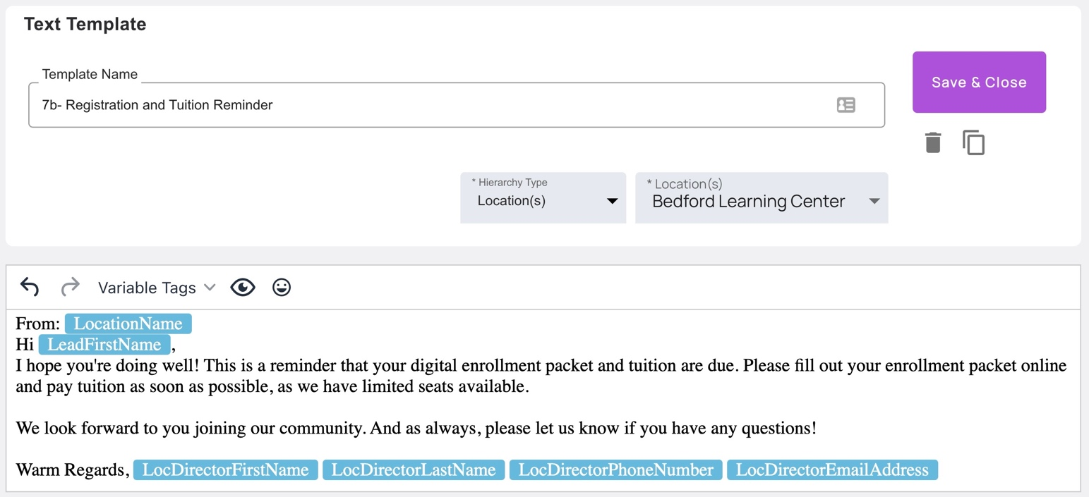Thanks for Joining the Waitlist: Text Template 6

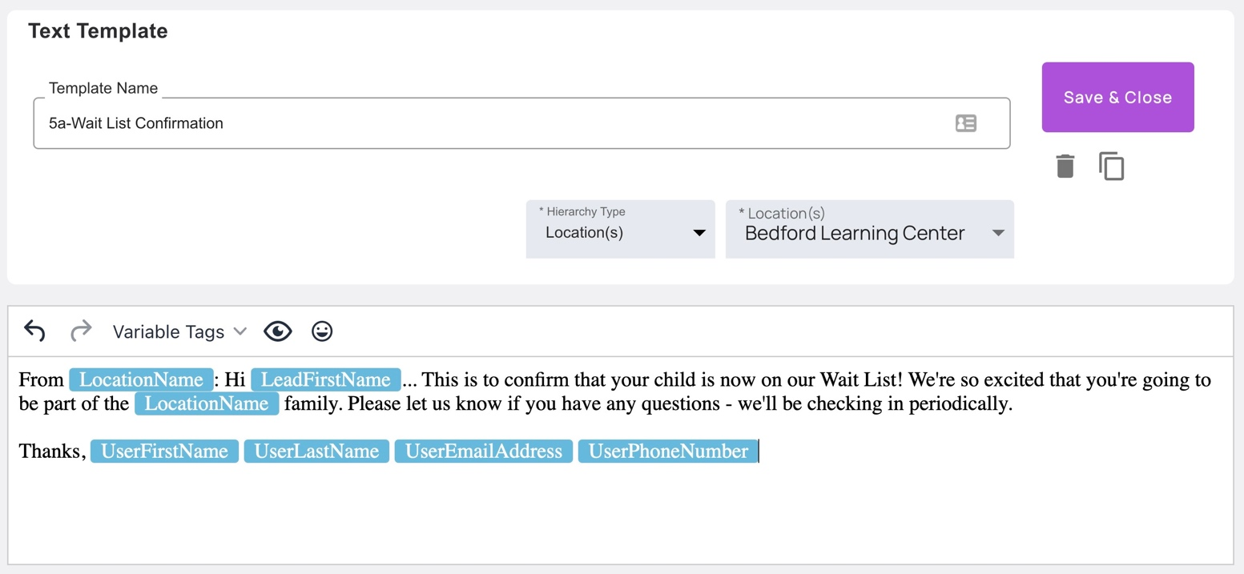

Enrollment Check-In [Pre-Start Date]: Text Template 7
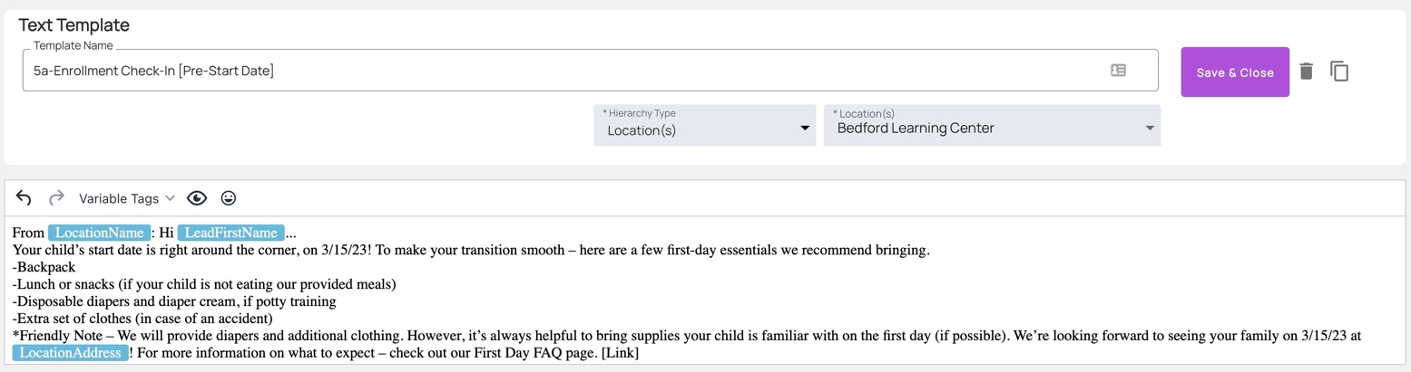Enrollment Start Date: Text Template 8
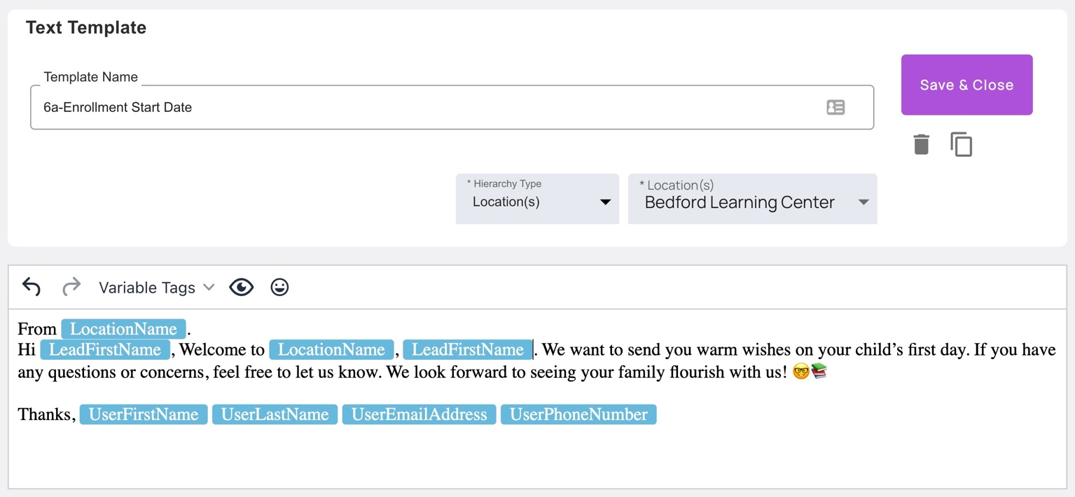Enrolled After 30 Days: Text Template 9
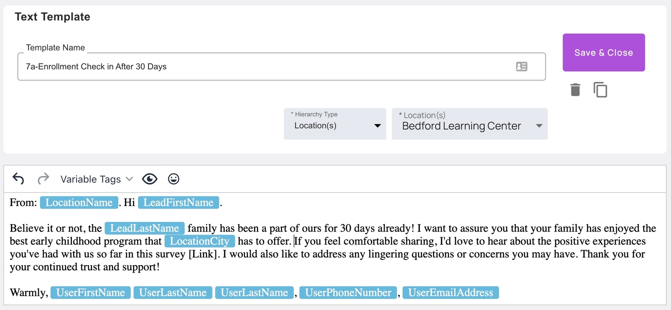Enrolled After 60 Days: Text Template 10
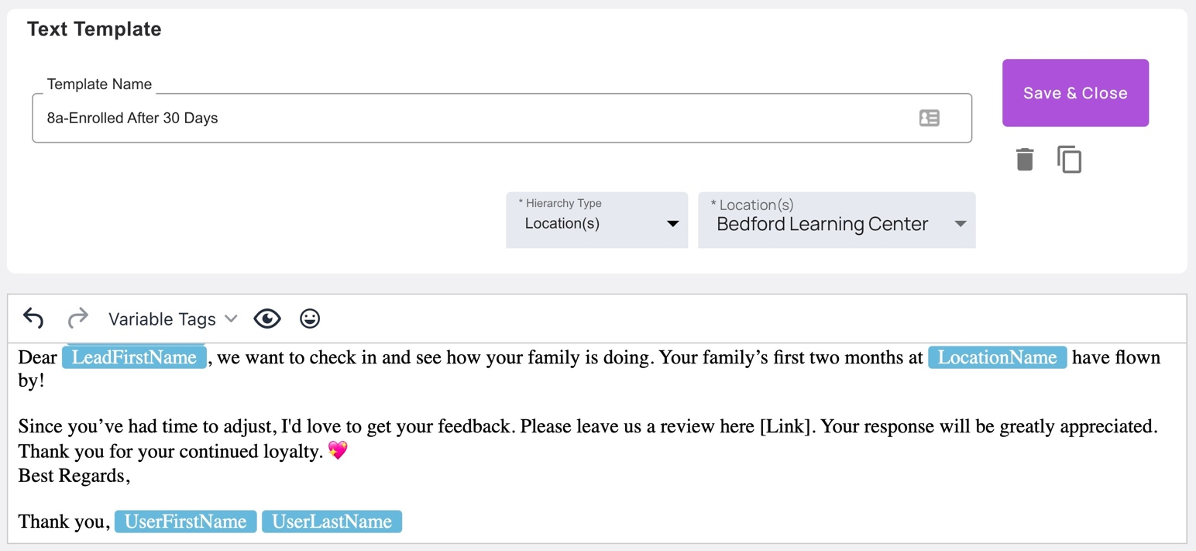Enrolled After 90 Days: Text Template 11
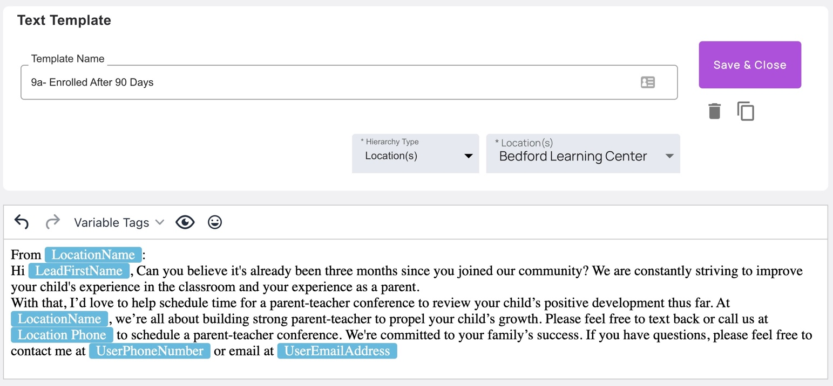
Time to Re-Enroll: Text Template 12
